CS607 - Artificial Intelligence.
BSCS | Pakistan.
Finalterm Current & Past Papers Spring 2025.
5.7 - 10.9
2025
- MCQs.
- Around 93% from [ Hina Shehzadi, Mahmeer Past Paper, & SAMU Past MCQs ] Files.

- Short Questions.
- Fuzzy logic is a subset of Boolean two logic. Statement is Correct or Not? Justify with solid reason.
- Any given learning problem is primarily composed of three things, just enlist three names.
- Describe the prime role of a Knowledge Engineer.
- Mention the working sets used in Candidate Elimination Process.
- Enlist the components of Action Predicates used in STRIPS.

- Long Questions.
- Related to Genetic Algorithm [ Out of Syllabus ].
- Write a CLIPS program which multiplies the two numbers i.e. 5 & 25 and print the result of it.
- There are various kinds of problems that require solutions. In theoretical computer science there are two main branches of problems, just enlist the names of branches and their sub-types.
- Which inference mechanism is well suited for design of automated diagnosis expert system? Justify with two solid reasons.

------------------------------------------------------------------------------------------------------------------------------------------

MCQs 2024.
> By SAMU.

1. Usually a _________ graph is chosen to represent a fuzzy set.
• Triangular

2. Many machine learning systems are _________.
• Classifiers

3. Inductive learning is based on the knowledge that if something happens a lot it is likely to be generally _________
• True

4. During ______ stage, the knowledge engineer works with the domain expert to acquire, organize, and analyze the domain knowledge.
• Knowledge acquisition

5. Machine learning typically follows ___________ phases according to Finlay.
• Three

6. In CLIPS, _____ command erases contents of working memory.
• (clear)

7. “Focused area of expertise” in human experts is referred to as _____ in expert systems
• Domain

8. The brain is a collection of about ___ interconnected neurons.
• 100 billion

9. Artificial Neural Networks is a new learning paradigm that takes its roots from ___ inspired approach to learning.
• Biology

10. Fuzzy logic is a subset of conventional (Boolean) logic.
• False

11. A classical set is a container, which wholly includes or wholly excludes any given element.
• True

12. The goal of ___________ is to analyze and structure the knowledge gained during the knowledge acquisition phase.
• Knowledge analysis

13. In backward chaining terminology, the hypothesis to prove is called the.
• Goal

14. ID stands for
• Interactive dichotomizer

15. Complex problems usually have well-defined steps.
• False

16. The Soma and the enclosed nucleus don't play a significant role in the processing of
• Incoming and outgoing data

17. Deals with procedures that extract useful information from static pictures and sequences of images.
• Computer vision

18. In unsupervised search a______ represents some specific underlying pattern in the Data.
• Cluster

19. In ANNs, MSE is known as:
• Mean Squared Error

20. Fuzzy logic is a superset of _____ logic.
• Conventional (Boolean)

three names of soft computing algorithm
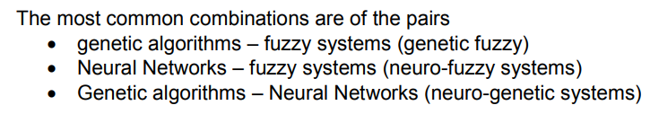

gain information ke statement the jis mai batana tha ke ye sahi h ya ghalt with reason
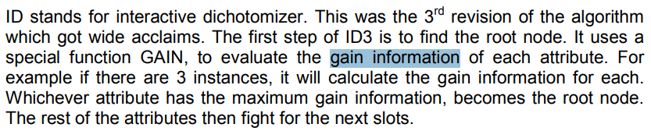

clips mai fact add ke command likhne the
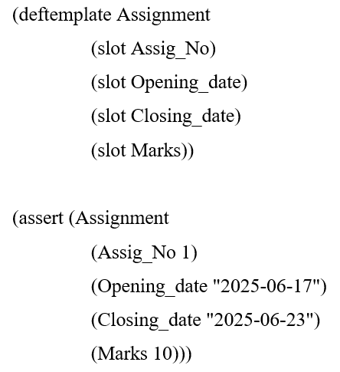

Clips mai facts ko remove karne ke command likhne the
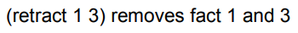

engineer designer wala ak question tha
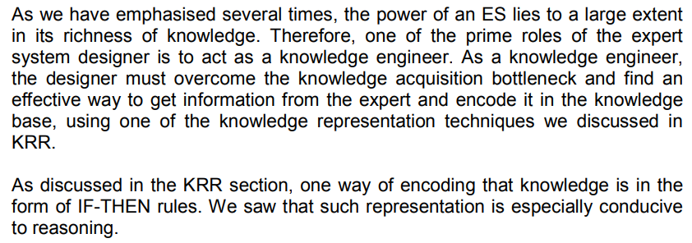

information gain and Entropy and its calculation
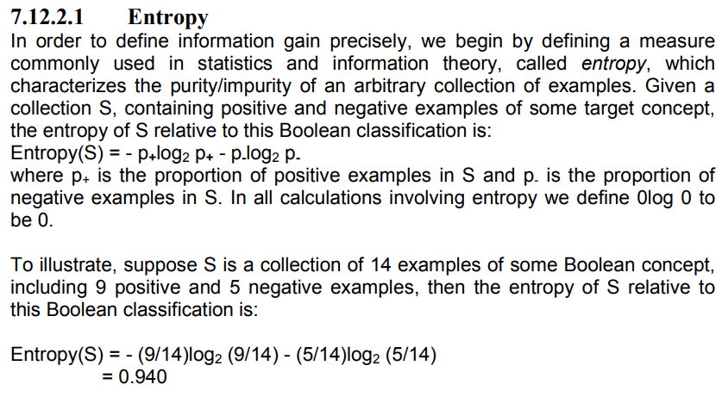
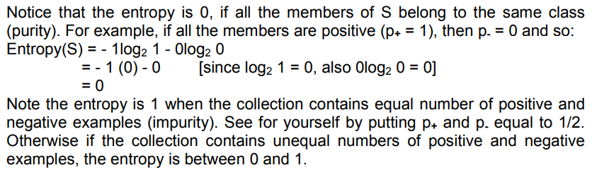

statement the or batana tha ke ke ye linearly seperable h ya non linearly separable with example
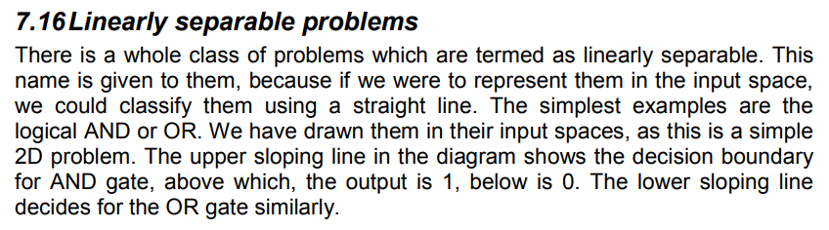
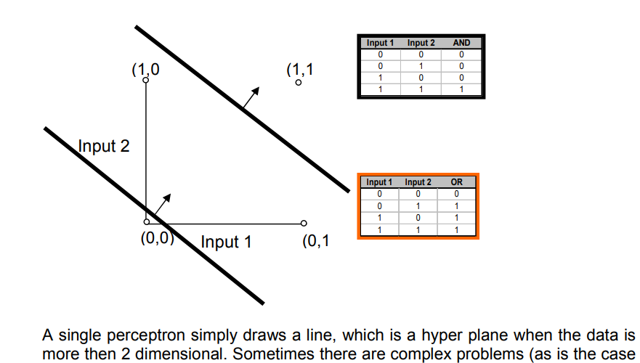
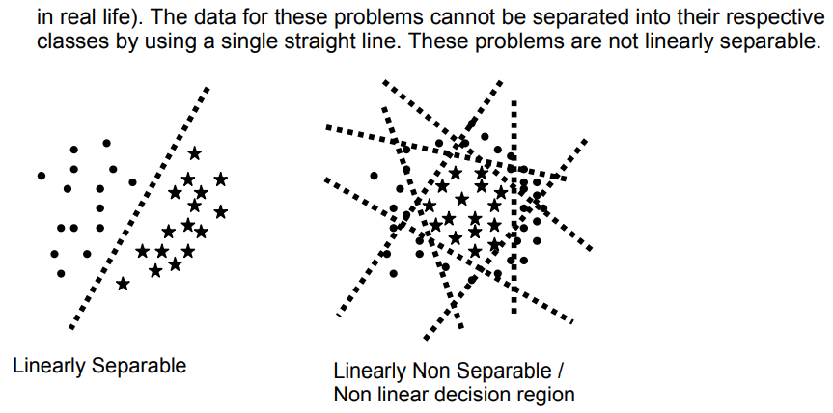
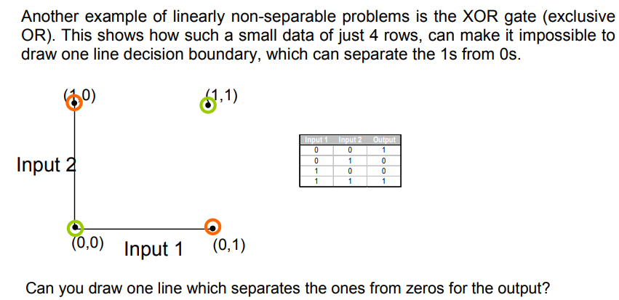
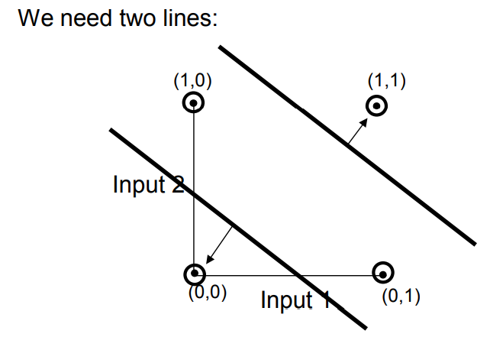
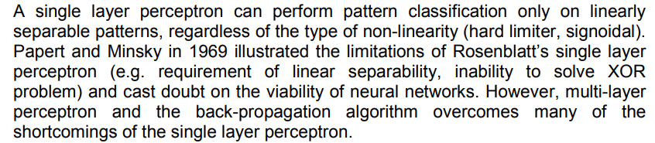

structure expert system diagrammatically
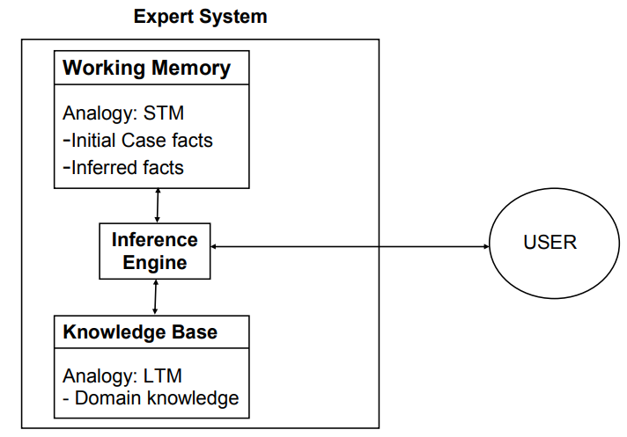
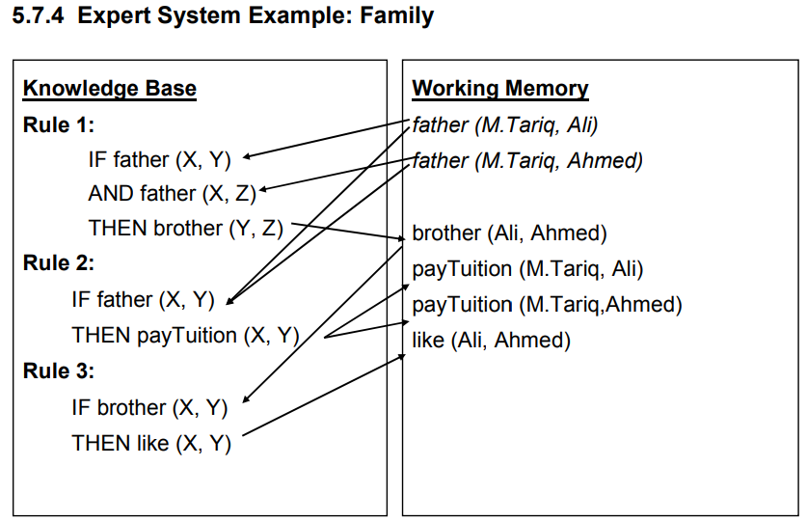
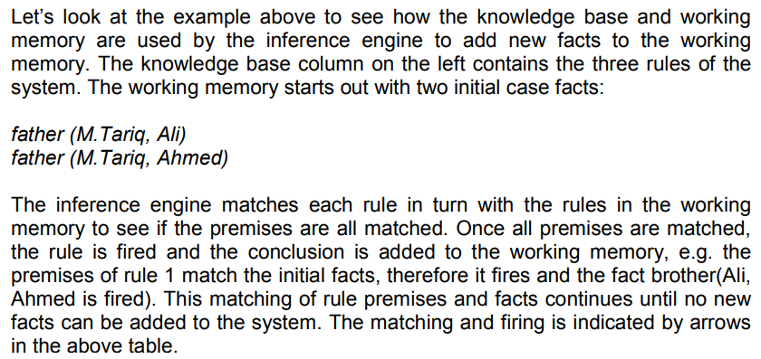

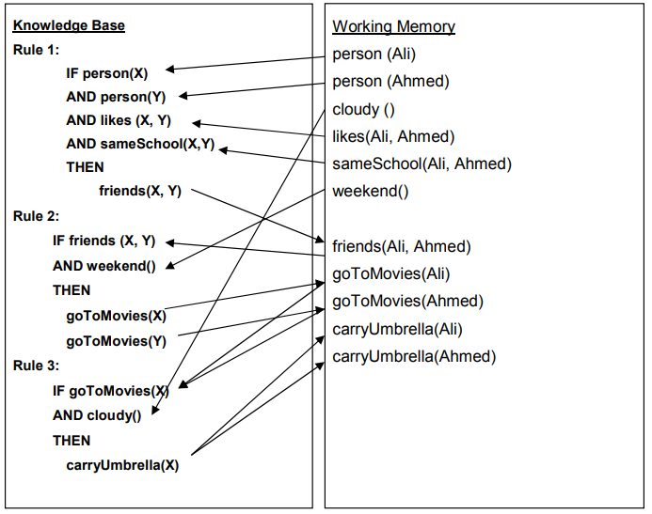

membership function with characters of fuzzy logic system
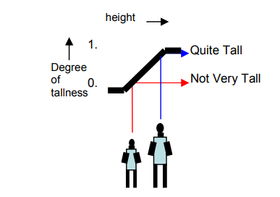
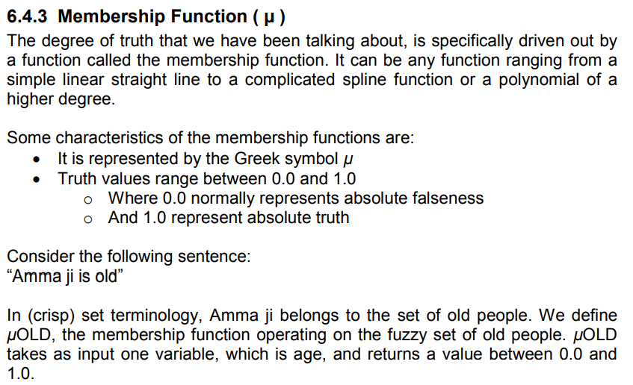
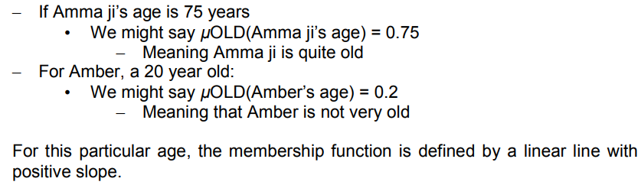

Difference between Supervised unsupervised.
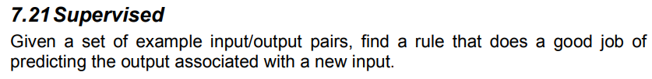
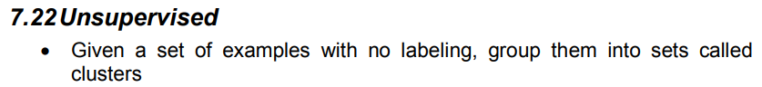

Machine learning.
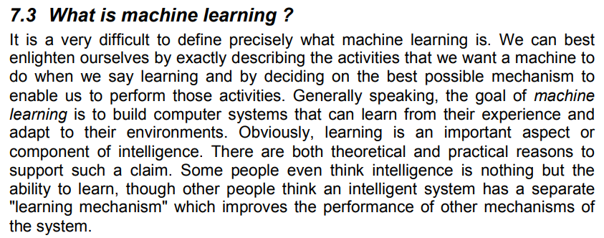
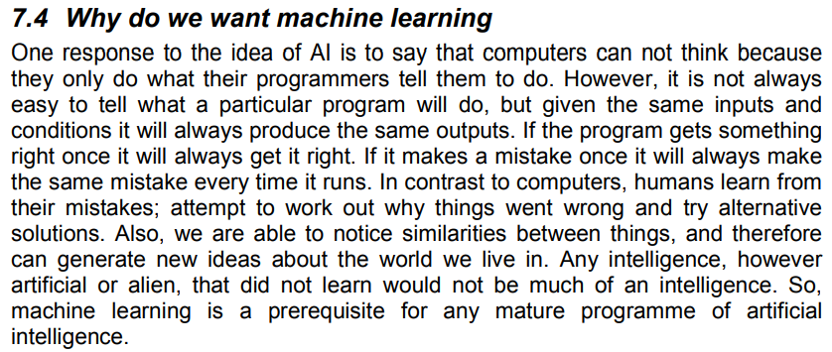
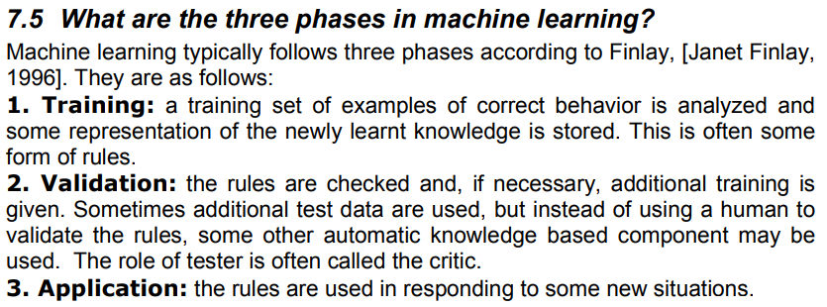
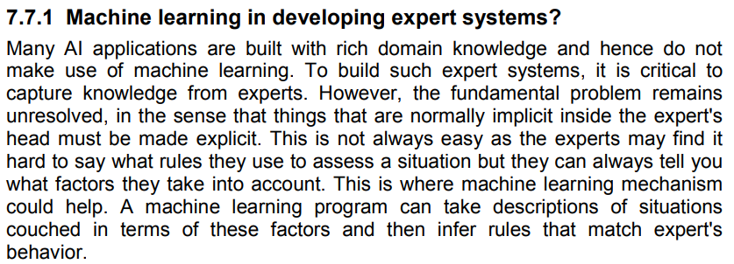

Connectionist sy related tha ek.
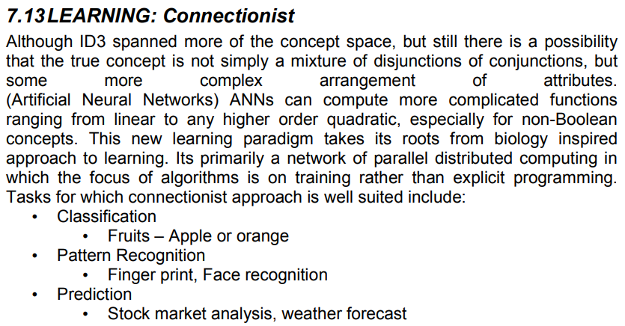

Knowledge acquisition.
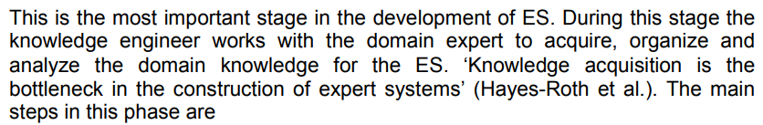
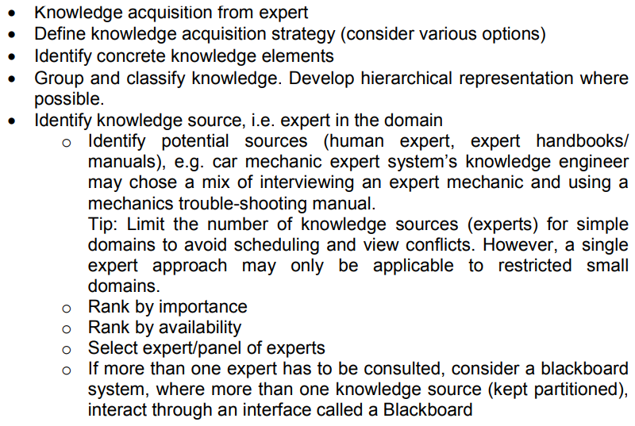
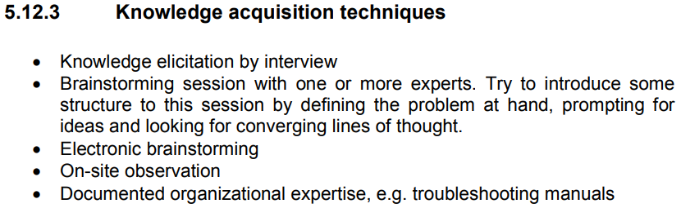

Diff tha concept ar instance space ka
- Instance space refers to all the possible examples or data points that you can have. For example, if you're thinking about classifying different animals, the instance space would be all the animals you're considering (like cats, dogs, birds, etc.), along with their features (size, color, etc.).
- Concept space, on the other hand, is about the ideas or categories that describe relationships between instances. It’s like a map of how these animals are grouped based on certain traits or behaviors. For example, the concept space would include categories like "mammals," "birds," and "reptiles," along with their defining features.
So, the instance space is about the specific examples of things you're studying, and the concept space is about the broader categories or patterns these examples fit into.

Clustering k 3 names likhny thy

Advantage of artificial neural network
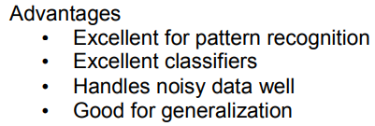

Stages of ESDLC
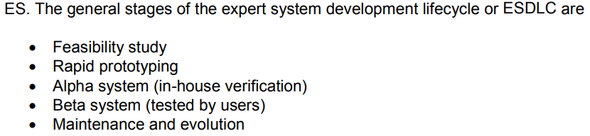

Elaborate last 3 drawback of neural network.
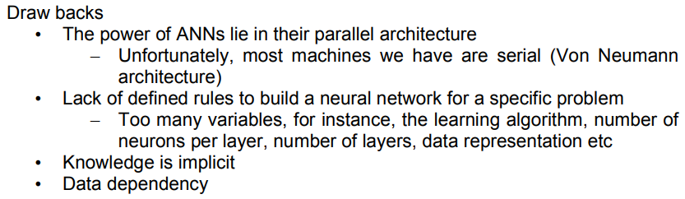

five names of fuzzy inference process
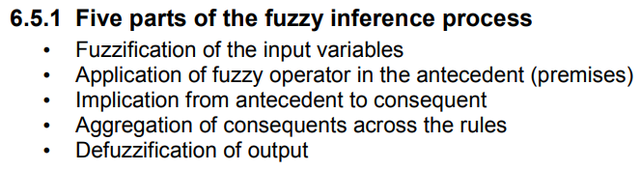

Clips cmd for printing hello world
(printout t “Hello World” crlf)

Which people are involved in expert system
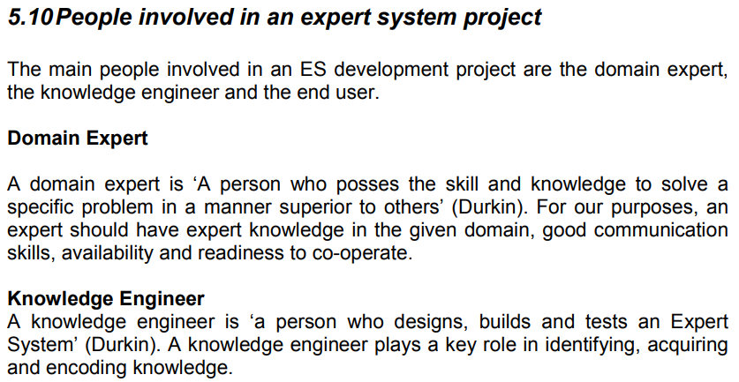
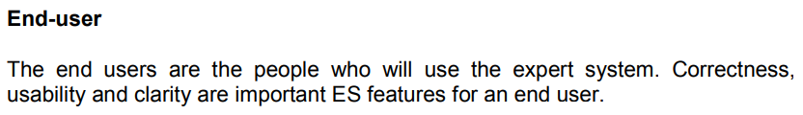

Decision tree
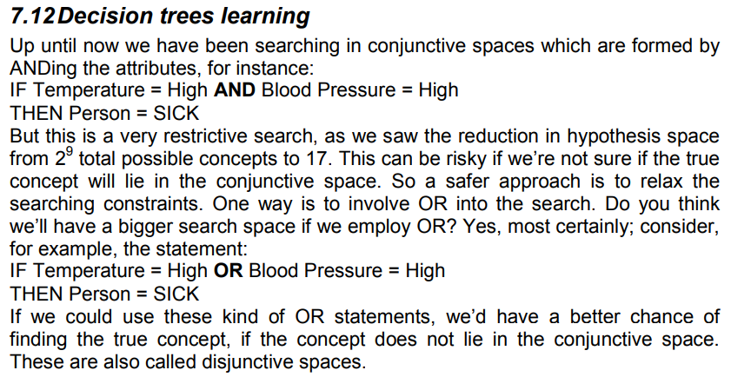
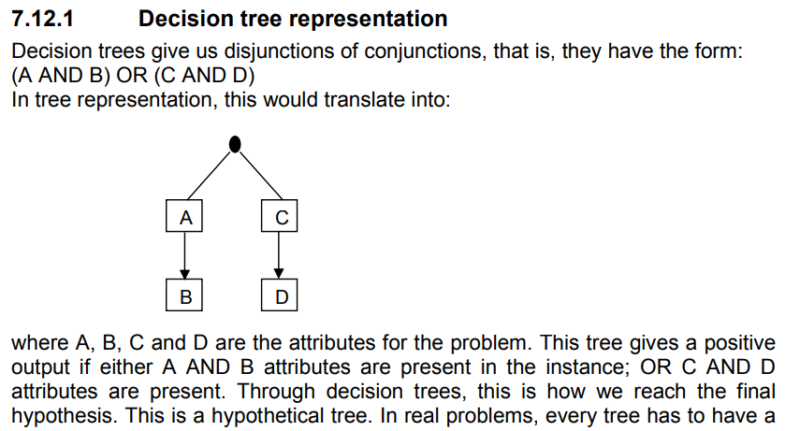

Difference between fuzzy and probability
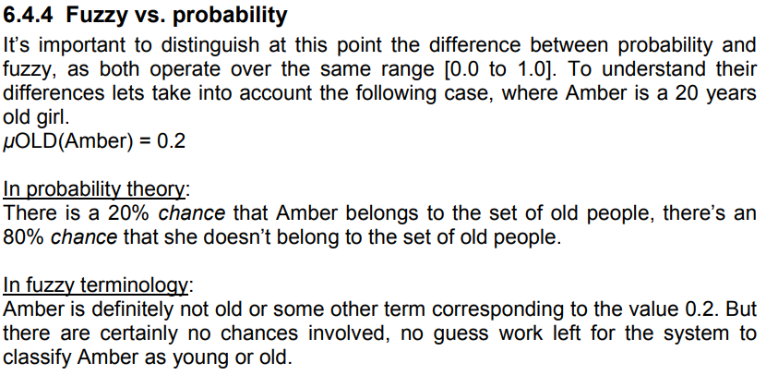

Action predicate
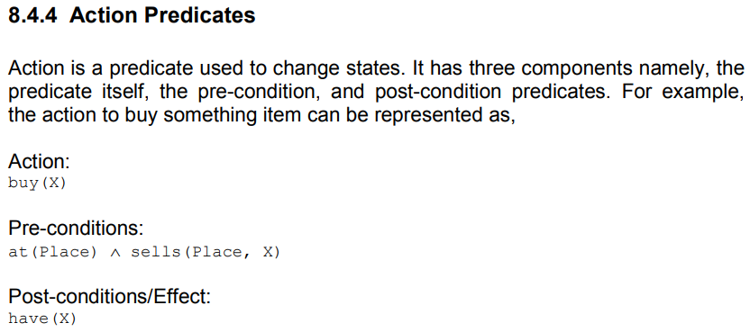

Candidate elimination algorithm 3 mark ka
The Candidate-elimination algorithm is a method used in machine learning to find the best hypothesis (or solution) from a set of possible hypotheses. It works by gradually eliminating impossible or unlikely solutions based on the examples it gets. The algorithm starts with a broad range of possible solutions, then narrows them down by checking whether each hypothesis fits with the positive and negative examples it encounters. It keeps only those hypotheses that can explain all the positive examples and none of the negative ones, eventually zeroing in on the most likely solution. Think of it like narrowing down answers to a tricky question by crossing out wrong options step by step.

( father ?name ) ( person $?name ) In this why the $ and ? is used in CLIPS language. ( 03 Marks )
- $ (Dollar Sign):
The $ is used to represent a "list" or a collection. It indicates that the value being matched is a group of things rather than a single item. For example, if you're trying to match a list of names in a fact, you'd use $ to show that you're matching the whole list, not just one name.
  - Example: (father $name) means "I’m looking for a fact that has a father and the name is a list." Here, $name could match something like John Mary (a list of names).
- ? (Question Mark):
The ? is used to represent a single, individual value. It means you’re matching one specific thing, and it acts as a variable. In the example (person $?name), it means "I'm looking for a fact about person and the name is a single, specific value."
  - Example: (person ?name) means "I’m looking for a fact that has a person and the name is something specific like Alice or Bob."

Putting it together:
- (father ?name) would look for a fact about a father where the name is a specific value (like John).
- (person $?name) would look for a fact about a person, and the name is a list (like John Mary or Alice Bob).
In short:
- ? = matches a single value.
- $ = matches a list or group of values.

What is aggregation? Is the output necessary in a fuzzy system in aggregation?
Aggregation in a fuzzy inference system (FIS) is the process where the results from different rules are combined to make a final decision. Each rule in the system produces a fuzzy set, which represents a possible outcome based on certain conditions. Aggregation takes these different fuzzy sets and combines them into one single fuzzy set that represents the overall output. This process happens right before the final step, called defuzzification, which converts the fuzzy set into a crisp value.
To put it simply, aggregation is like collecting all the different suggestions from each rule and putting them together into one clear suggestion. The output of each rule is necessary for aggregation because it’s what gets combined to form the final decision. Without these individual outputs, there would be nothing to combine, and the system wouldn't be able to make a proper decision.

In "Biological Neural Network" and " Computer" which is better in terms of speed? Also explain with reason. ( 03 Marks )
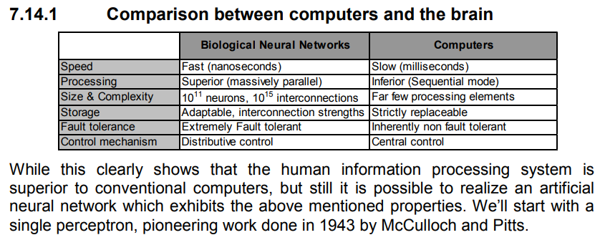

The different programming languages have some data types defined. What are the 5 defined data types of CLIPS language. ( 05 Marks )
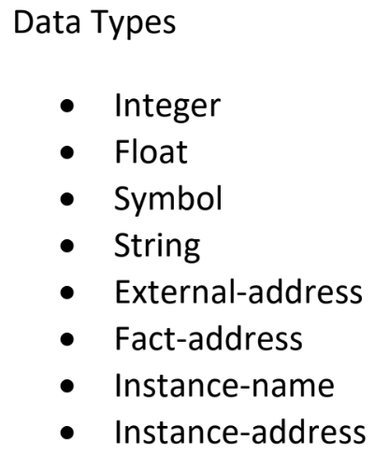

Three types of windows in CLIPS
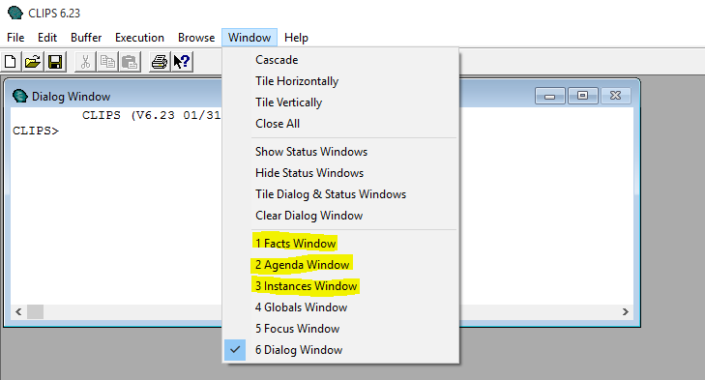

Decision tree was given and we have to write the representation.
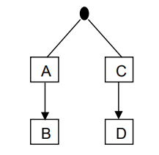
(A AND B) OR (C AND D)

Use Clips command to show product of two numbers ... numbers given
(* 3 4)

Forward Channing disadvantages
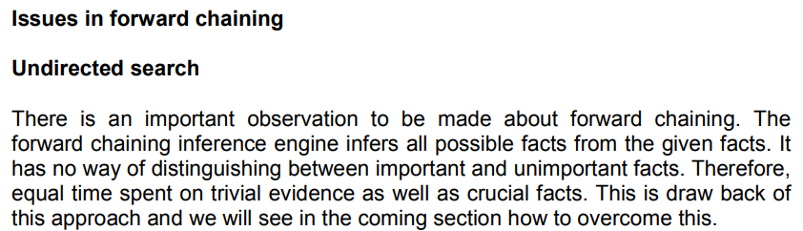
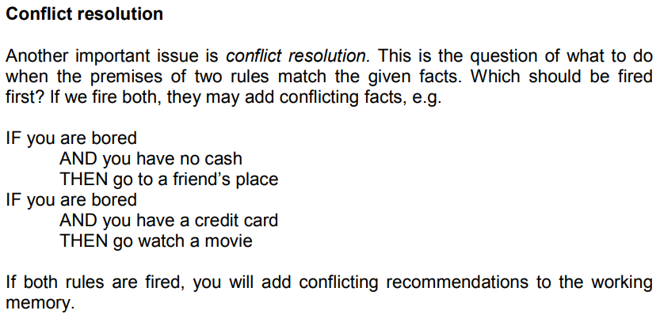

Clips command used to add and modify facts
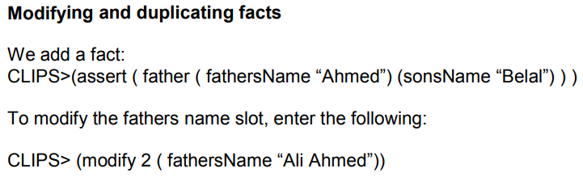

linear model phases
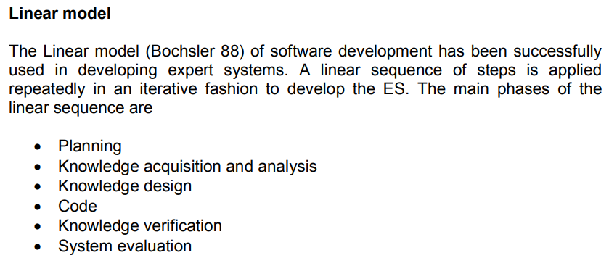

knowledge analysis ka pucha tha
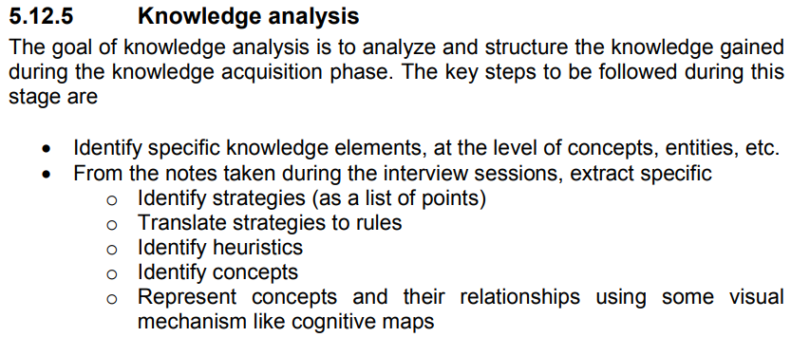
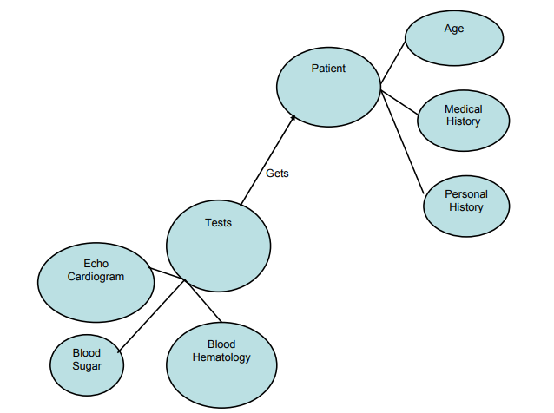
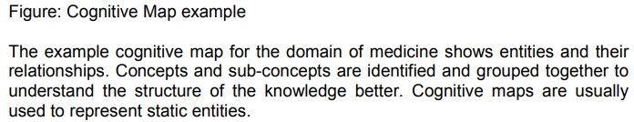

Fuzzy is a subset of Boolean two logic. Statement is Correct or Not? Give reason
The statement is incorrect.
Fuzzy logic is not a subset of Boolean logic. Boolean logic deals with binary values (True or False), while fuzzy logic allows for a range of values between 0 and 1, representing degrees of truth. In fuzzy logic, things can be partially true or false, unlike in Boolean logic where something is either true or false.

Difference between Formal Forward and Backward chaining
- Direction of Inference:
  - Forward chaining starts with facts and moves toward a conclusion.
  - Backward chaining starts with a goal and works backward to find facts.
- Goal-driven or Data-driven:
  - Forward chaining is data-driven.
  - Backward chaining is goal-driven.
- Process Flow:
  - Forward chaining is like "if this, then that."
  - Backward chaining is like "to achieve this, what do I need?"
- Usage:
  - Forward chaining is used when you have lots of data and need to find conclusions.
  - Backward chaining is used when you have a specific goal and need to find how to achieve it.
- Example:
  - Forward chaining: Diagnosing a problem based on symptoms.
  - Backward chaining: Finding out how to reach a desired outcome by breaking down the steps.

Difference between fuzzy logic and Boolean value.
Boolean logic is all about two values: True or False (1 or 0). It's like a light switch—either on or off.
Fuzzy logic is more flexible. It deals with values between 0 and 1, like a dimmer switch. So, instead of just "on" or "off," it can be partially on (e.g., 0.5 or 70%) depending on the situation. It handles uncertainty and vagueness.
In short:
- Boolean: 0 or 1 (exact).
- Fuzzy: Any value between 0 and 1 (approximate).

A classical set is a container, which wholly includes or wholly excludes any given element. This statement is correct or not? Give reason
Yes, the statement is correct. A classical set only includes elements that belong to it, or it excludes elements that don't. It's like a box that either holds an item completely or doesn't hold it at all—nothing in between.

